Healthcare Business Question | MS SQL Server Query | Output  Note: If there are more than 20 rows, only the first 20 are shown.
Demographics and Diagnoses:  What is the demographic profile of the patient population, including age and gender distribution? | 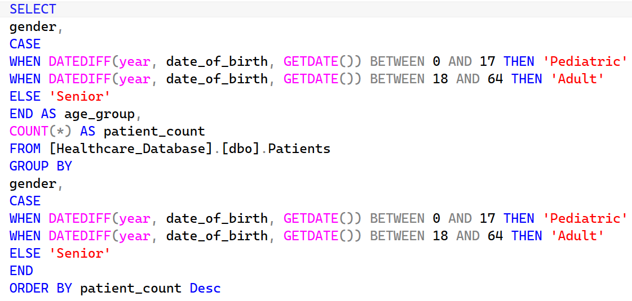 | 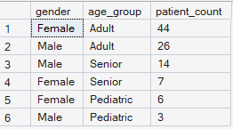
Demographics and Diagnoses:  How do diagnoses vary across different demographic groups, including gender and age? | 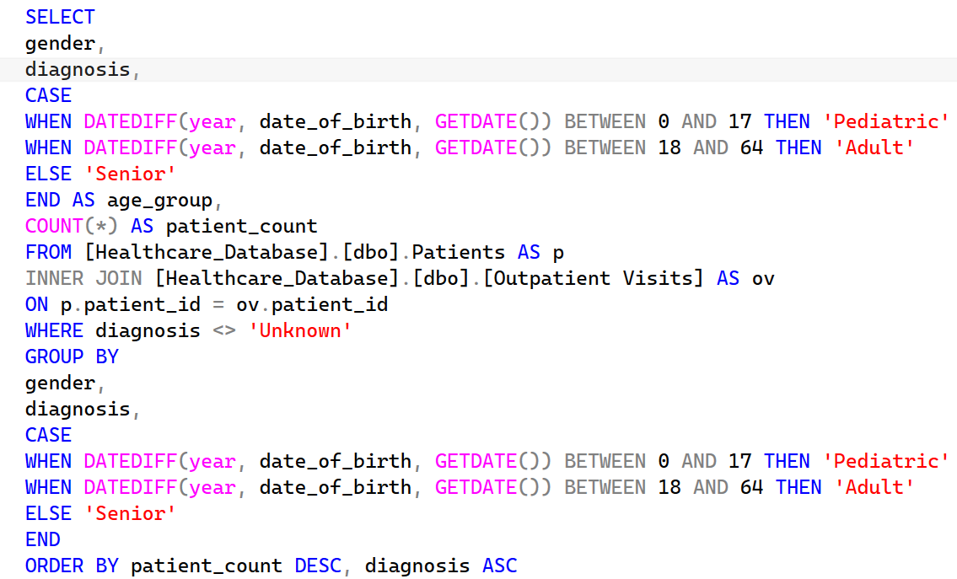 | 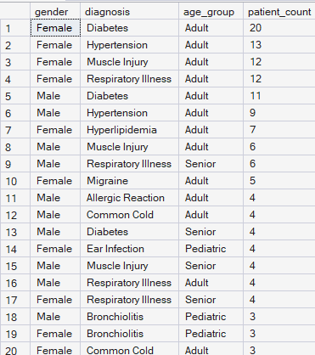
Demographics and Diagnoses:  Which diagnoses are more prevalent among patients? | 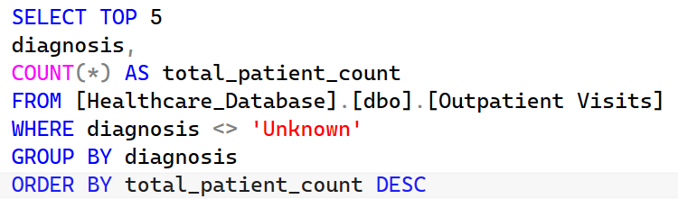 | 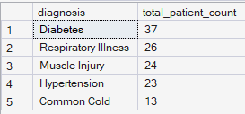
Appointments:  What are the most common appointment times in the day, and how does the distribution vary? | 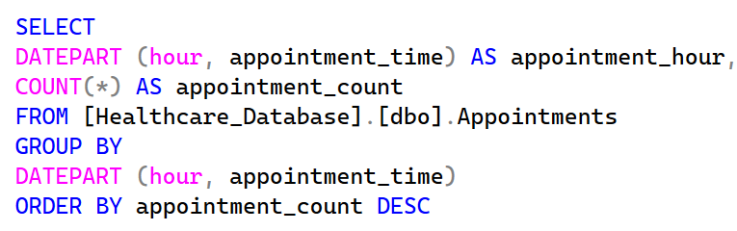 | 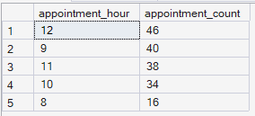
Labs:  What are the most commonly ordered lab tests? |  | 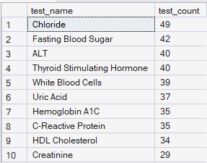
Labs:  Typically, fasting blood sugar levels falls between 70-100 mg/dL. Our goal is to identify patients whose lab results are outside this normal range to implement early intervention. | 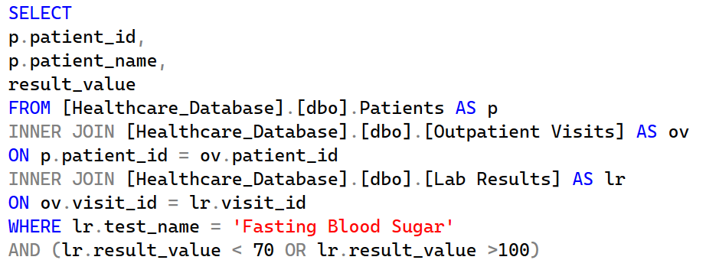 | 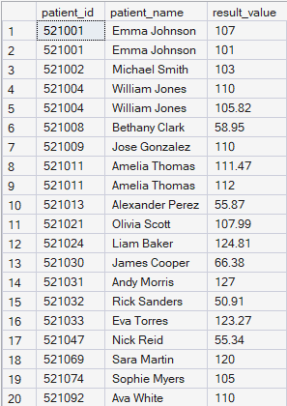
Risk Stratification:  How many patients are considered High, Medium, and Low Risk?  High Risk: patients who are smokers and have been diagnosed with either hypertension or diabetes.  Medium Risk: patients who are non-smokers and have been diagnosed with either hypertension or diabetes.  Low Risk: patients who do not fall into the above categories. | 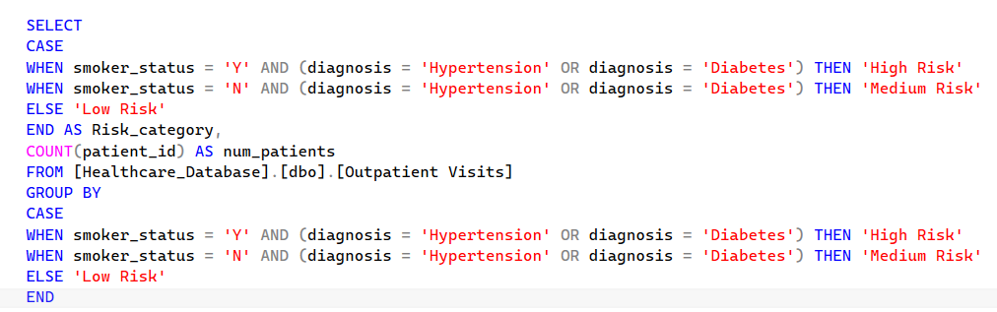 | 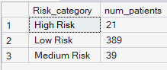
Readmissions:  Which patients had multiple visits within 30 days of their previous medical visit? | 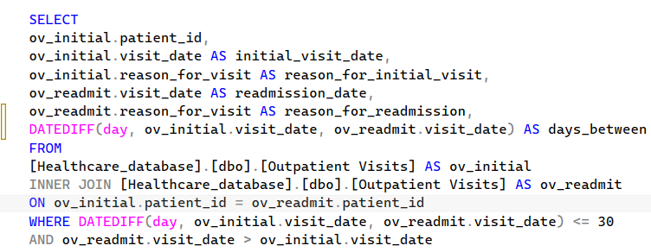 | See below for detailed output.
Detailed Output
